AGT1 - MODULE-2

Objectives
- Understand Map Algebra
- Use Raster Calculator tool
- Use Int tool
- Use Arithmetic operators
- Use Boolean And
- Use Combinatorial And
- Use Over tool
- Use Diff tool
- Use InList Tool
Deliverables (To be submitted)
- Map showing use of each tool/operator. (Screenshot not Map Layout)
Lab Settings
Use Data in folder: AGT1-Data/Module2

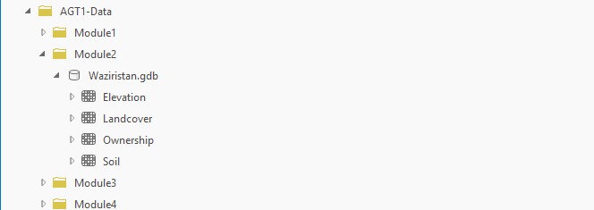
Scenario
Imagine you are on a mission to restore the lush forests of Waziristan.
To succeed, you have to play the role of a "Nature Architect" using the language of Map Algebra to decode the landscape.
Think of Map Algebra as a superpower that lets you stack different layers of the Earth like a mathematical sandwich to reveal secrets hidden in the terrain.

Raster Calculator
The Raster Calculator is a powerful spatial analysis tool in ArcGIS (available in both ArcMap and ArcGIS Pro) that allows you to perform complex mathematical calculations on raster datasets using Map Algebra.
Think of it as a scientific calculator where the "numbers" you input are actually entire grids of geographic data.
Goal: Use Raster calculator.
Scenario: The elevation data is initially recorded in feet, but the project requires metric units for volume and suitability calculations. You use the Times (multiply) operator to multiply the elevation by 0.3048.

Add Elevation (Raster) Data:
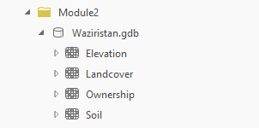

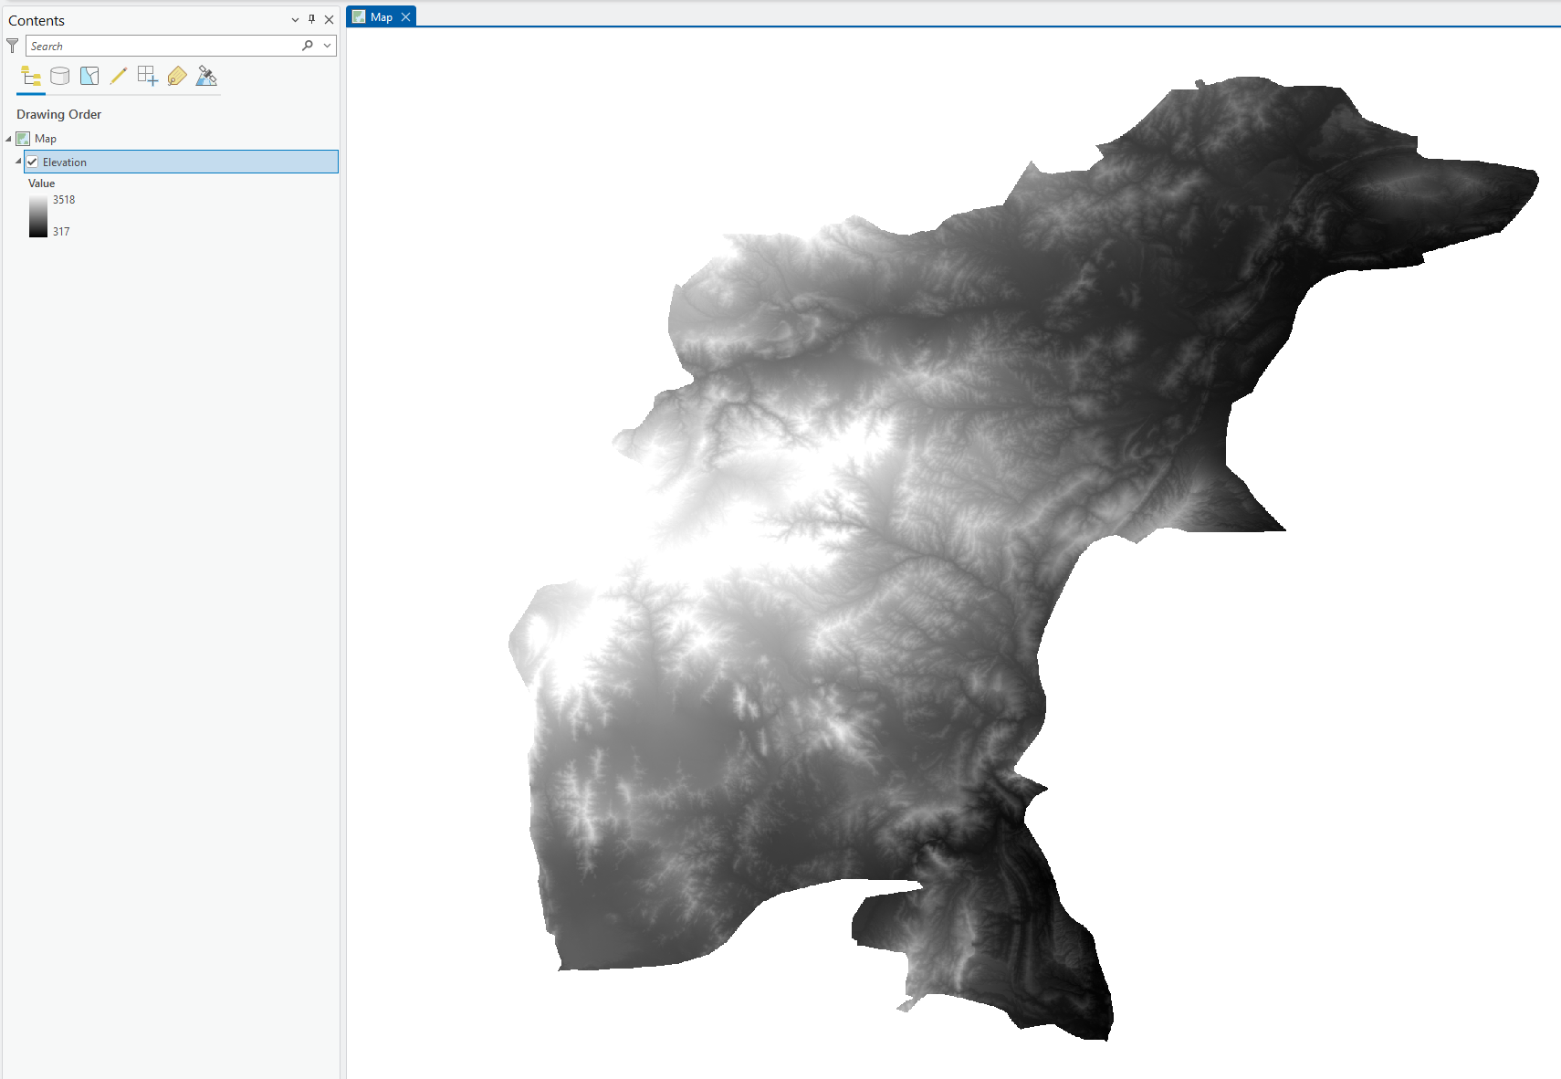

Open Raster calculator (spatial analyst):
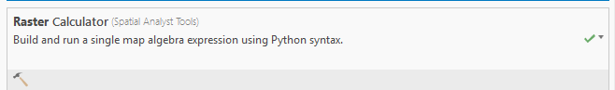

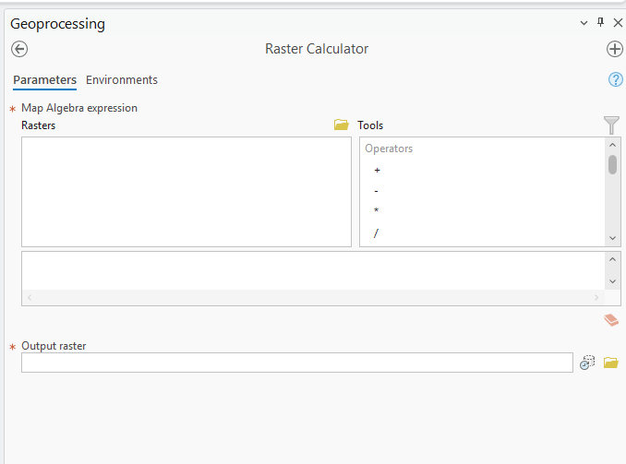

Use the variables and operators available to write the following expression:
"Elevation" *0.3048
Note: Double-clicking on a variable or operator adds it to the expression.
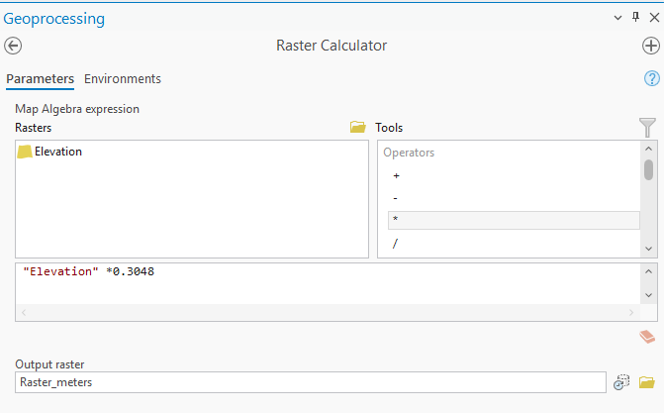
Hit Run:
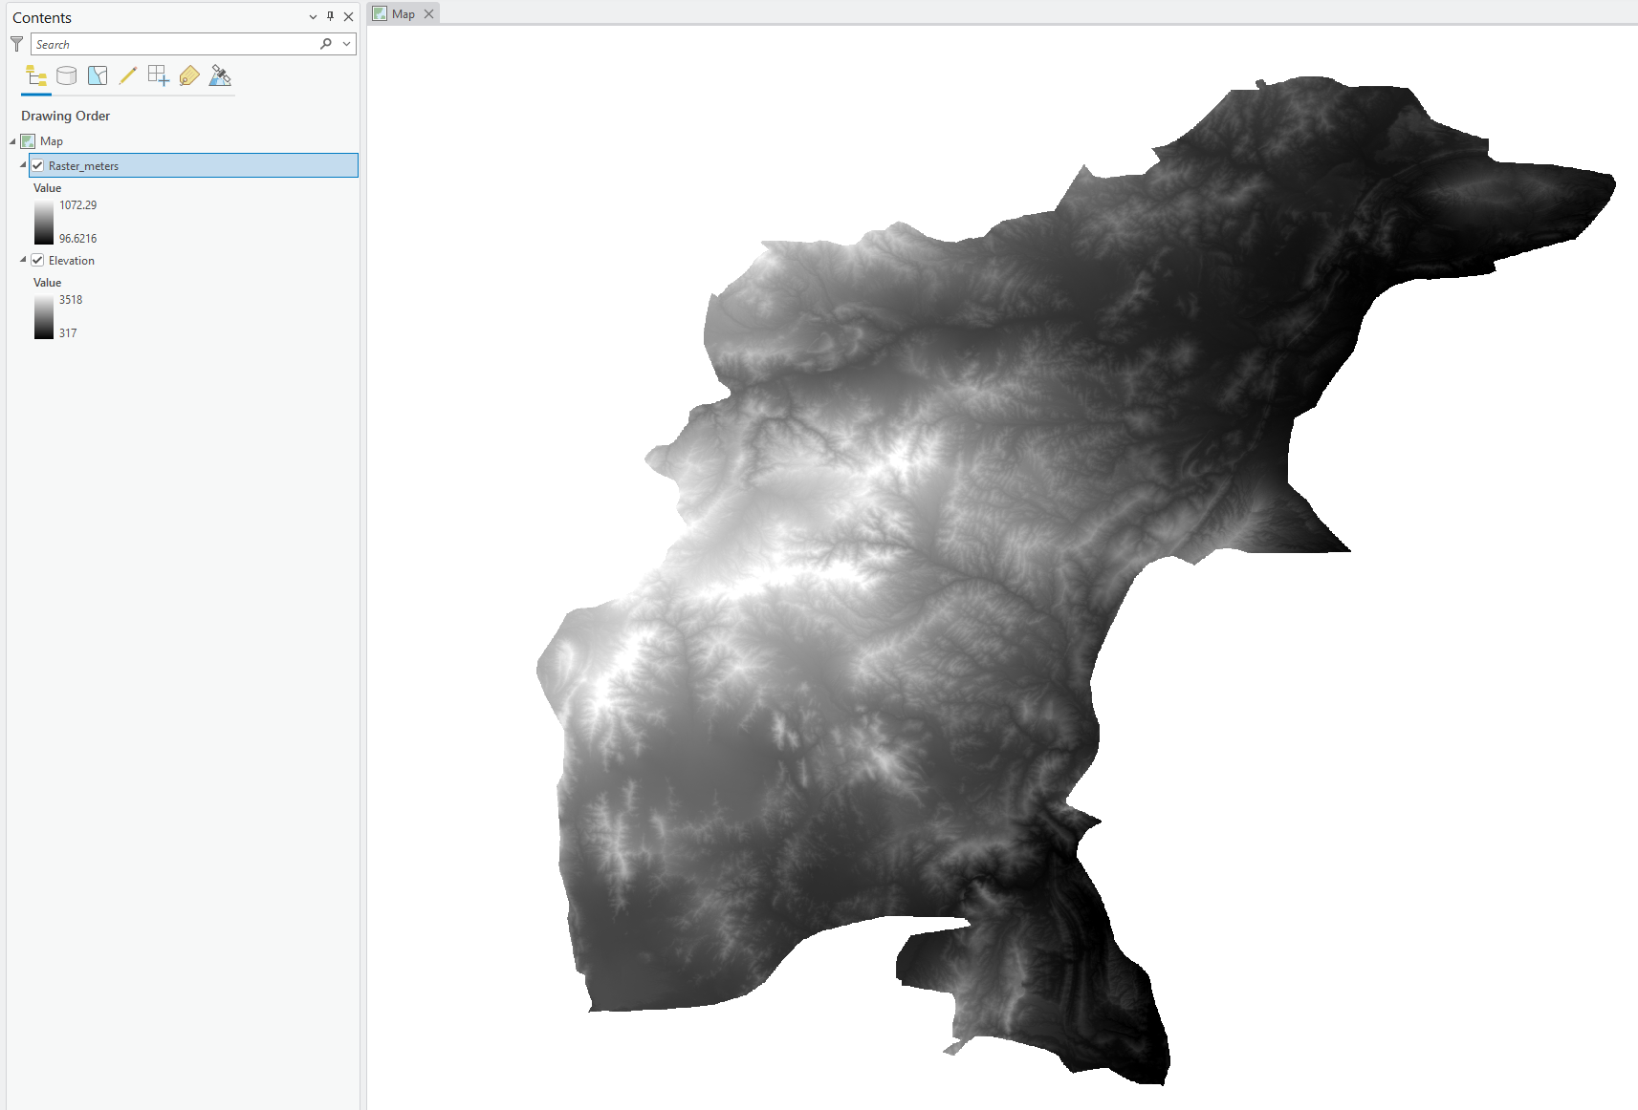

A new DEM with values in meters has been generated. (Note the change in values ion the legend).

Int Tool
The Int tool converts a floating-point raster into an integer raster by truncating the decimal values (e.g., 5.9 becomes 5).
Its primary purpose is to transform continuous data into discrete categories, which allows ArcGIS to generate a Raster Attribute Table for further analysis. This is essential when you need to perform operations that require integer inputs, such as calculating the area of specific classes.

Goal: Use Int Tool.
Scenario: To keep the data clean for processing, the Int function is then used to truncate those results into whole integers.

Open Int tool:
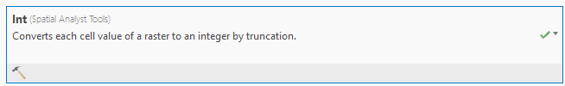
Configure it as follows:
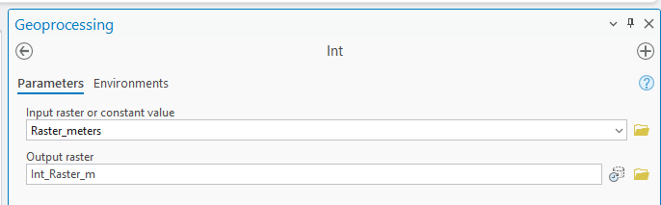

Hit Run:
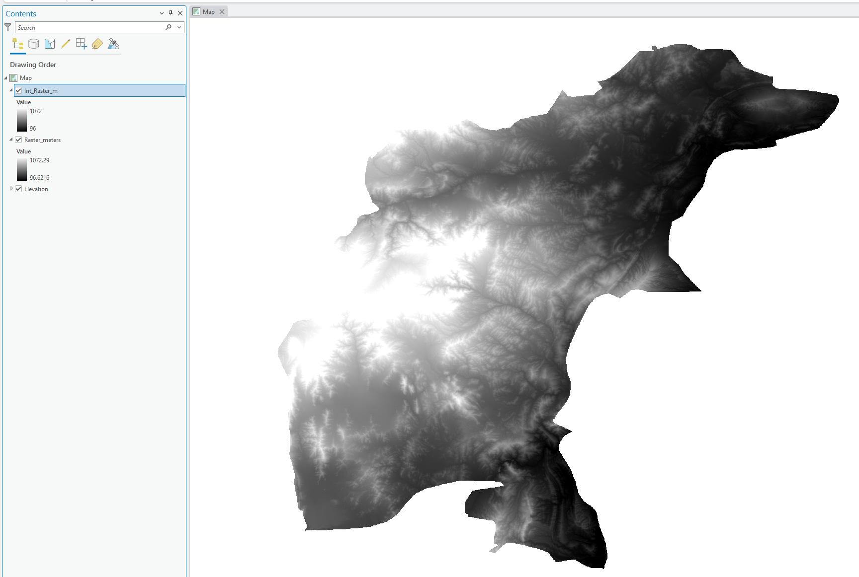

Note that the values in Legend have been truncated (Rounded Off).

Note: We can perform the same in Raster calculator as well!
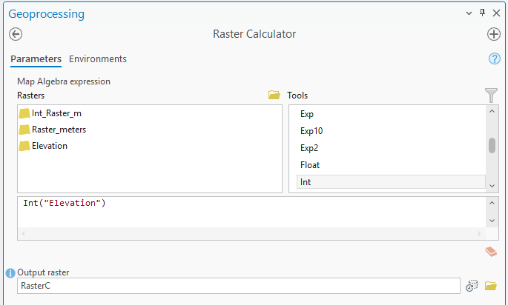

Greater Than Tool
The Greater Than (>) tool performs a logical comparison that identifies which cells in a raster are larger than another value or raster.
It outputs a binary result, where cells meeting the condition are assigned 1 (True) and those that do not are assigned 0 (False).
This is a fundamental operation for masking data or isolating specific features, such as identifying terrain with an elevation higher than a set threshold.

Goal: Use Greater than Tool.
Scenario: The target pine and fir trees grow best at altitudes above 900 meters.

Open Greater Than tool.
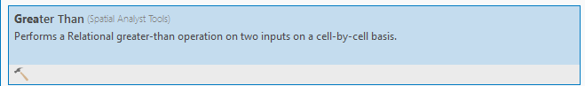
Configure as follows:
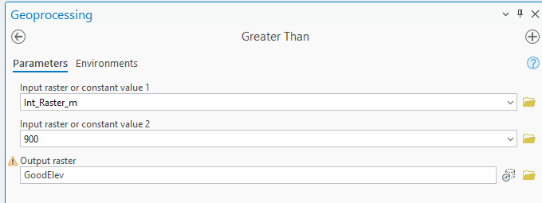
Hit Run:
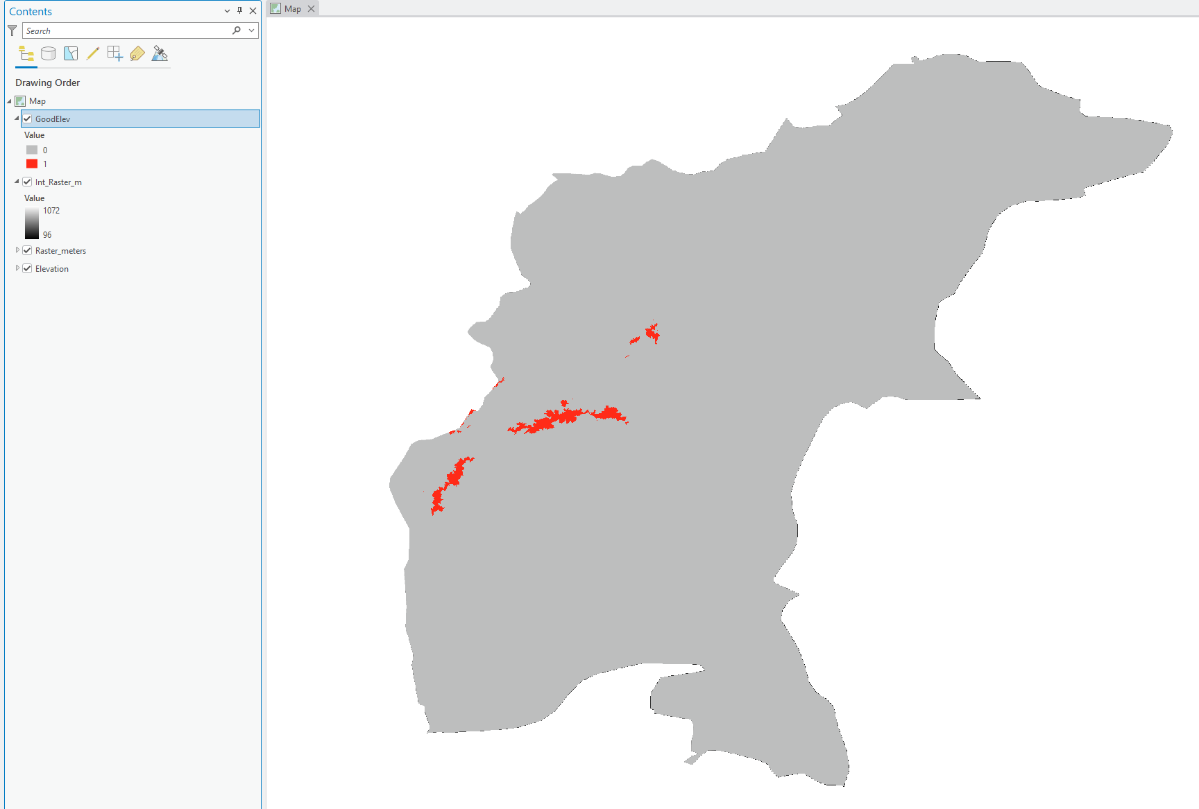

Note: We can perform the same in Raster calculator as well!
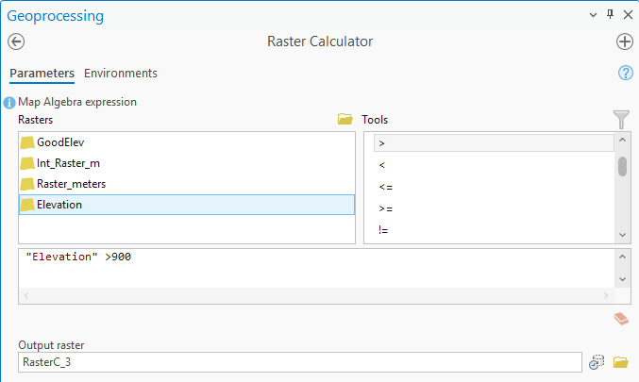

Equal To Operator
The Equal To (==) tool performs a cell-by-cell comparison to determine if values in two rasters (or a raster and a constant) are identical.
It produces a boolean output where matching cells are assigned 1 (True) and non-matching cells are assigned 0 (False).
This operator is frequently used in land-use analysis to isolate specific categories or to create binary masks for spatial modeling.

Goal: Use Equal To Operator.
Scenario: You must also ensure the land is owned by the Pakistan Forest Service.

Load Ownership (Raster):
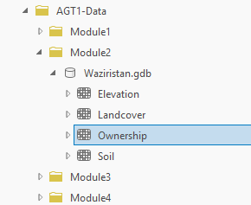
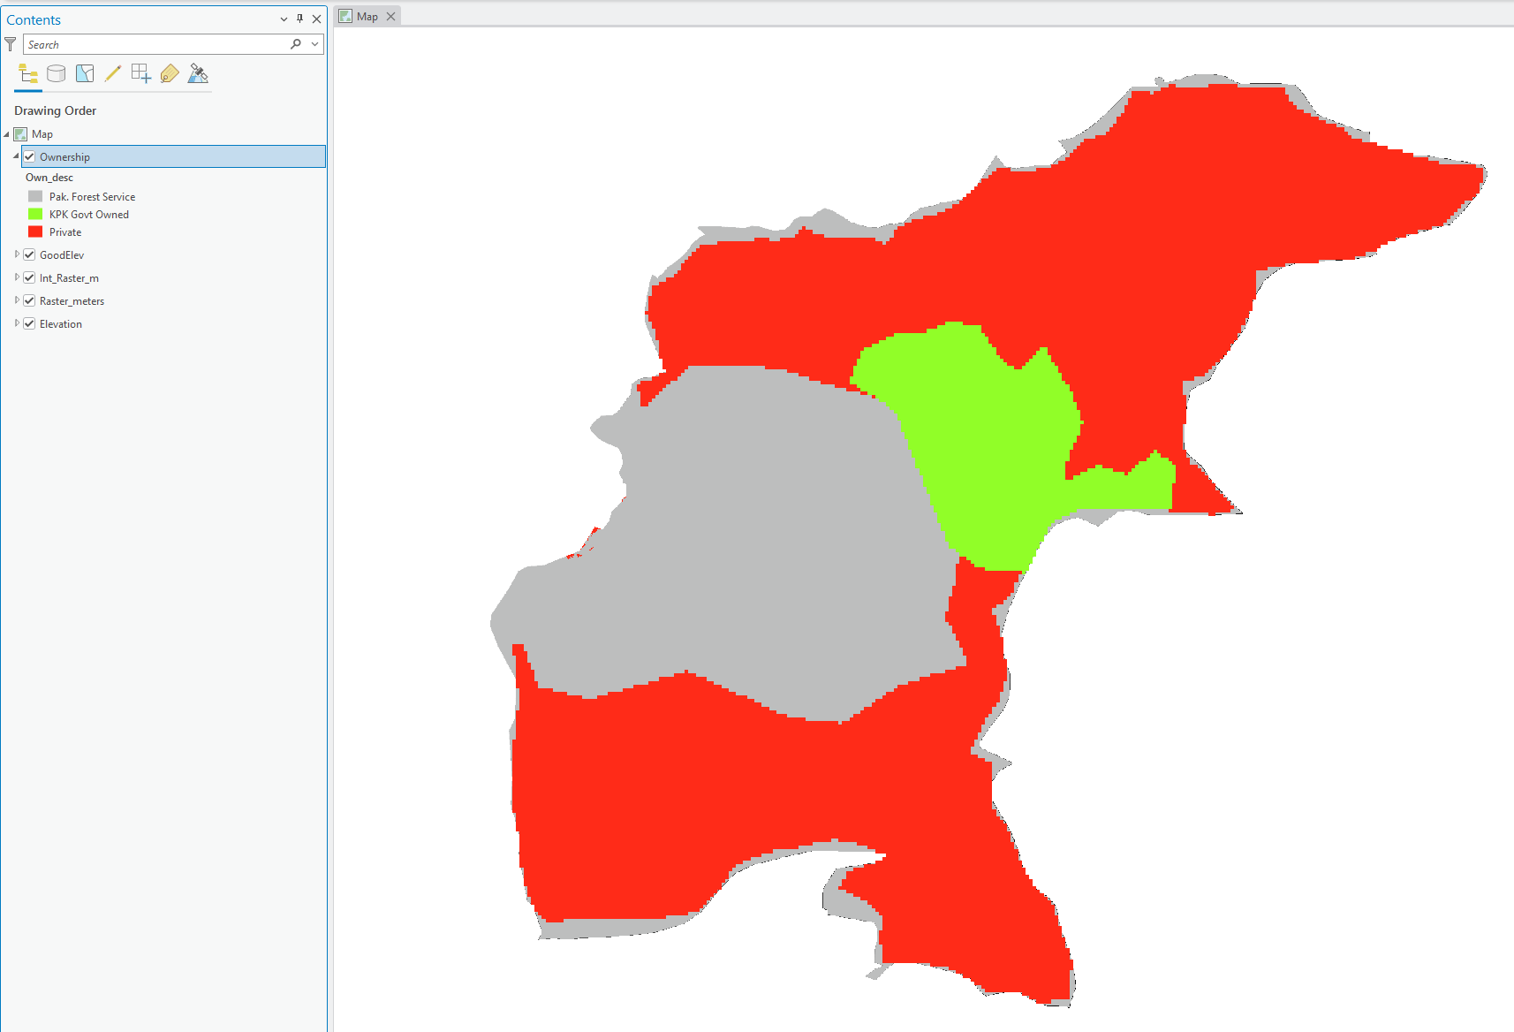

Explore the raster’s attributes:
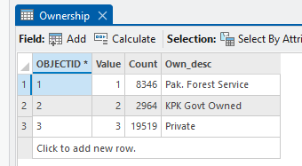
We see that a value of 1 indicates that the land is owned by Pak Forest Service.
We will now use the equal to operator to identify such cells as True (1):
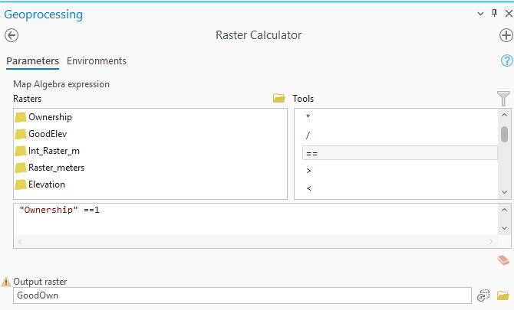
Hit Run:
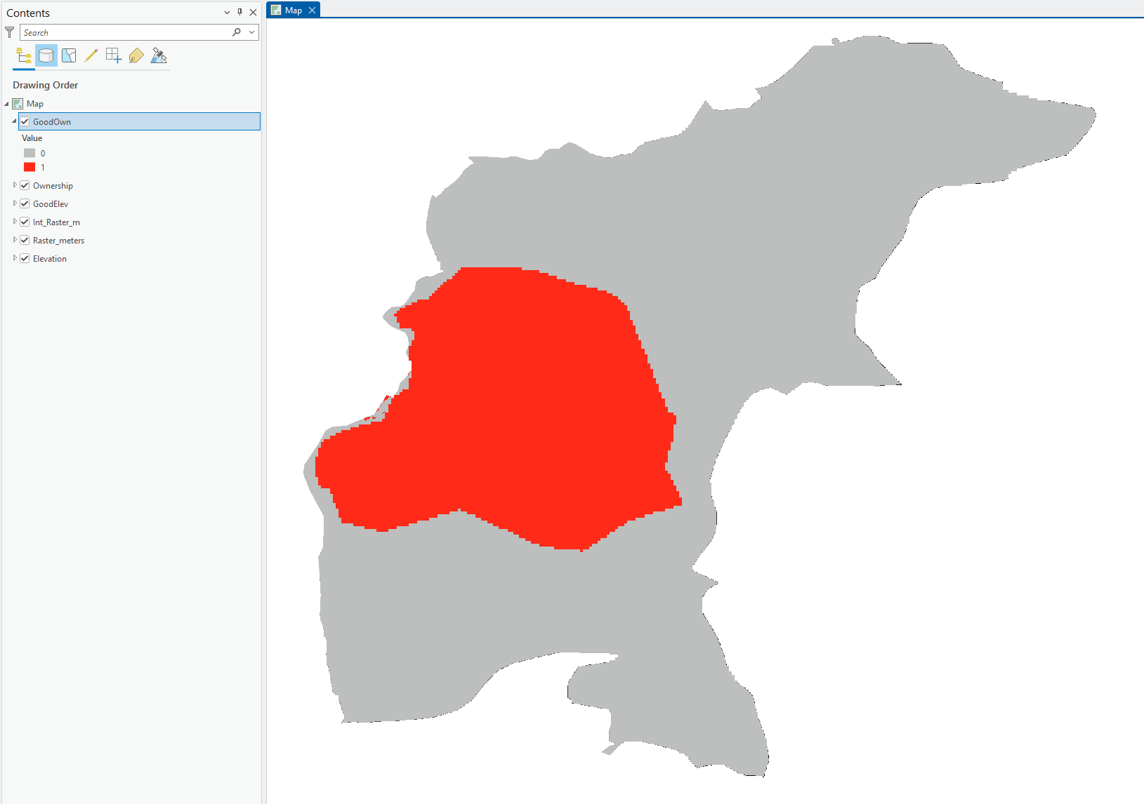
Boolean And Tool
The Boolean And (&) tool performs a logical evaluation where a cell in the output is assigned 1 (True) only if the values in both input rasters are non-zero.
If either (or both) input cells are zero, the output is assigned 0 (False).
It is essentially an "intersection" operation, commonly used in suitability modeling to find areas where multiple required criteria are met simultaneously.
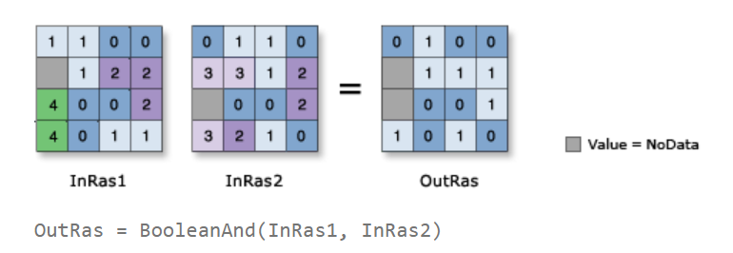

Goal: Use Boolean And Operator.
Scenario: Find areas where both requirements (height & ownership) are met simultaneously.

Open Boolean AND tool:
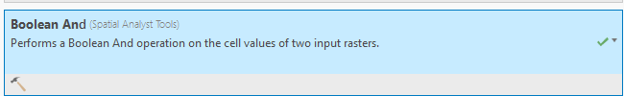

Configure as fol:
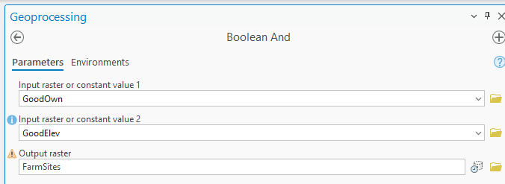
Hit Run.
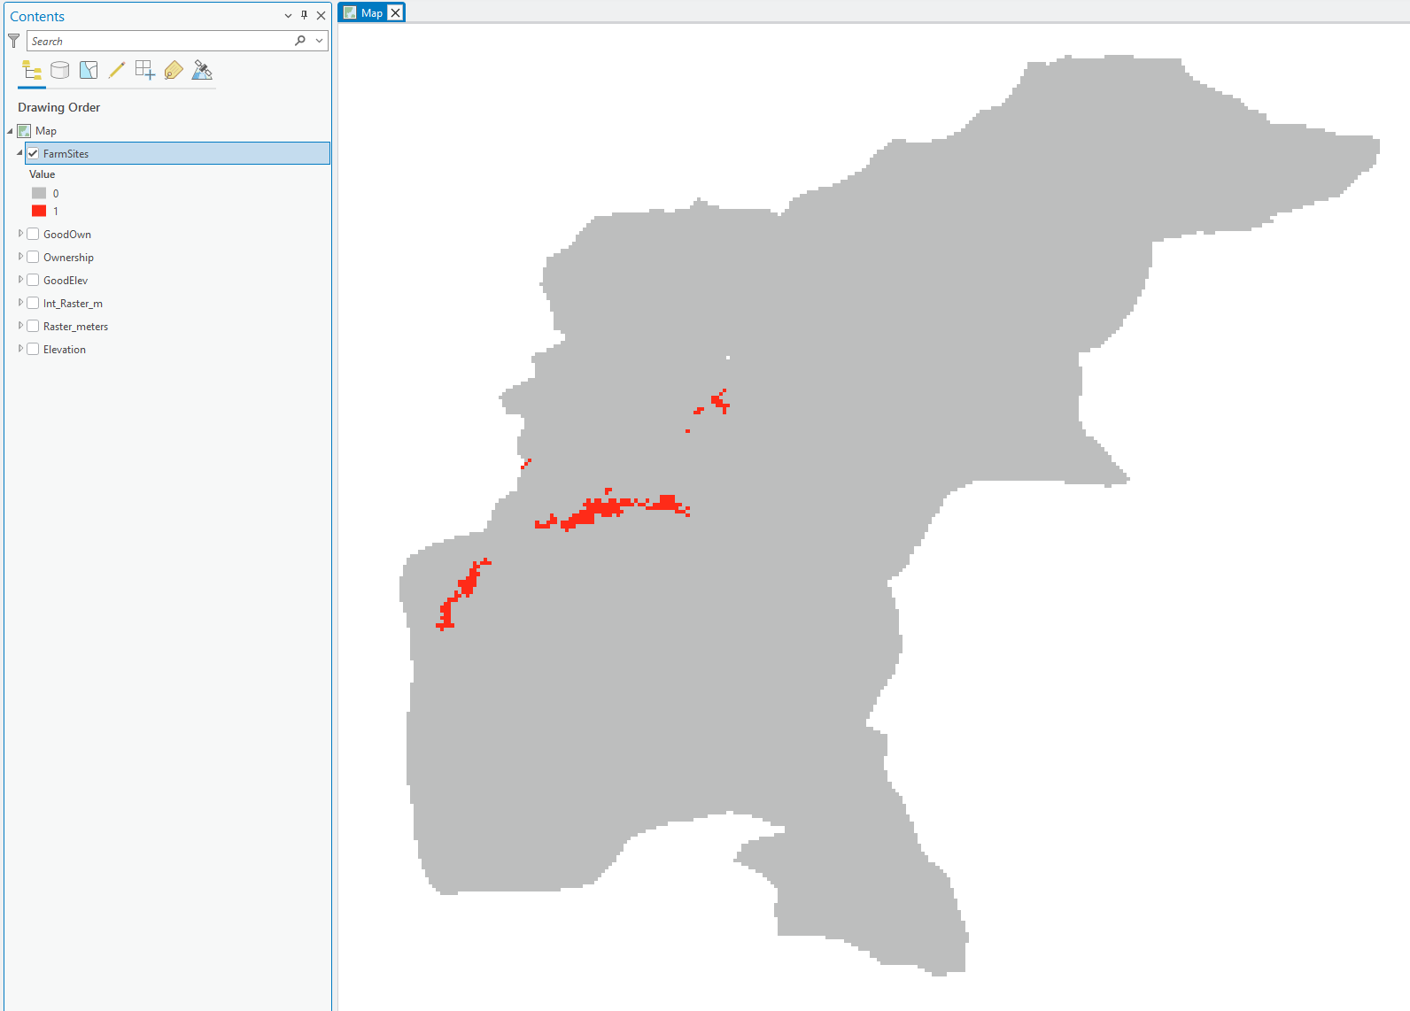

Note: We can perform the same in Raster calculator as well!
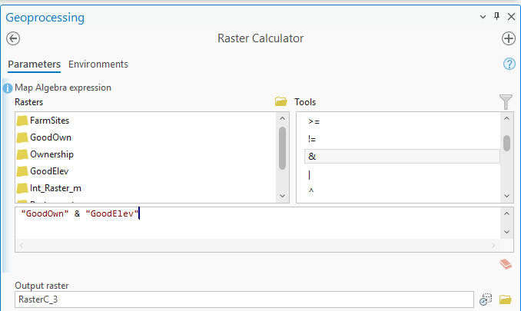

Combinatorial AND
The Combinatorial And (CAND) tool performs a cell-by-cell logical evaluation of two or more rasters, but unlike Boolean AND, it preserves the unique combinations of the input values.
While Boolean AND only tells you if both inputs are true (1) or false (0), CAND assigns a unique integer to every distinct overlapping pair of input values and records these combinations in an attribute table.
This allows you to track exactly which specific attributes from the original layers are present in each cell of the output, making it superior for complex multi-criteria overlays.
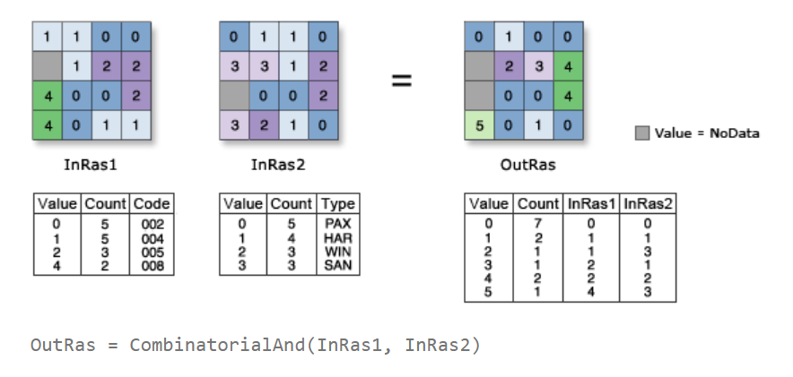
Imagine you have two different maps, and you want to find the spots where both maps have something special.
Boolean AND is like a simple "Yes/No" filter. It only cares if both maps have anything there. If Map A has a tree and Map B has a rock, the output just says "Yes, both have something." It throws away the details and only gives you a 1 (Yes) or a 0 (No).
CAND (Combinatorial And) is like a "Memory" filter. It doesn't just say "Yes"; it remembers exactly what was on each map.
If Map A has a "Pine Tree" and Map B has a "Granite Rock," CAND creates a new category called "Pine Tree + Granite Rock." It keeps a list (an attribute table) of every unique combination it finds, so you don't lose the specific details from your original maps.

Goal: Use CAND (Combinatorial AND) Tool.
Scenario: Now that we have selected our Farm Sites, add soil attributes to them.
Load Soils (Raster):
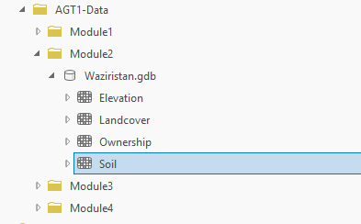
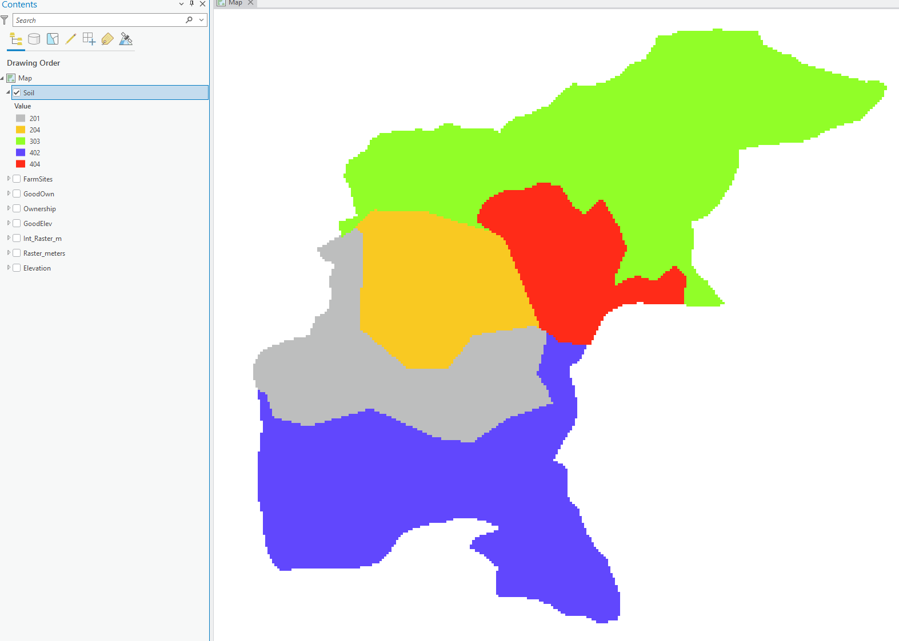

Explore attribute table:
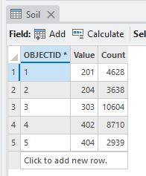

Open Combinatorial AND tool:
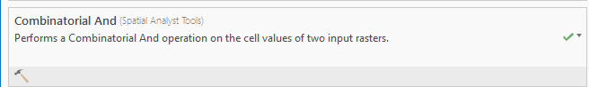
Configure as follows:
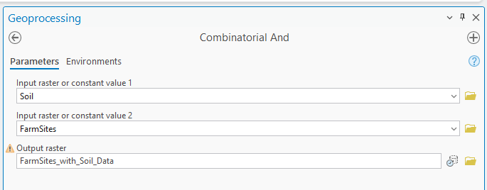

Hit Run:
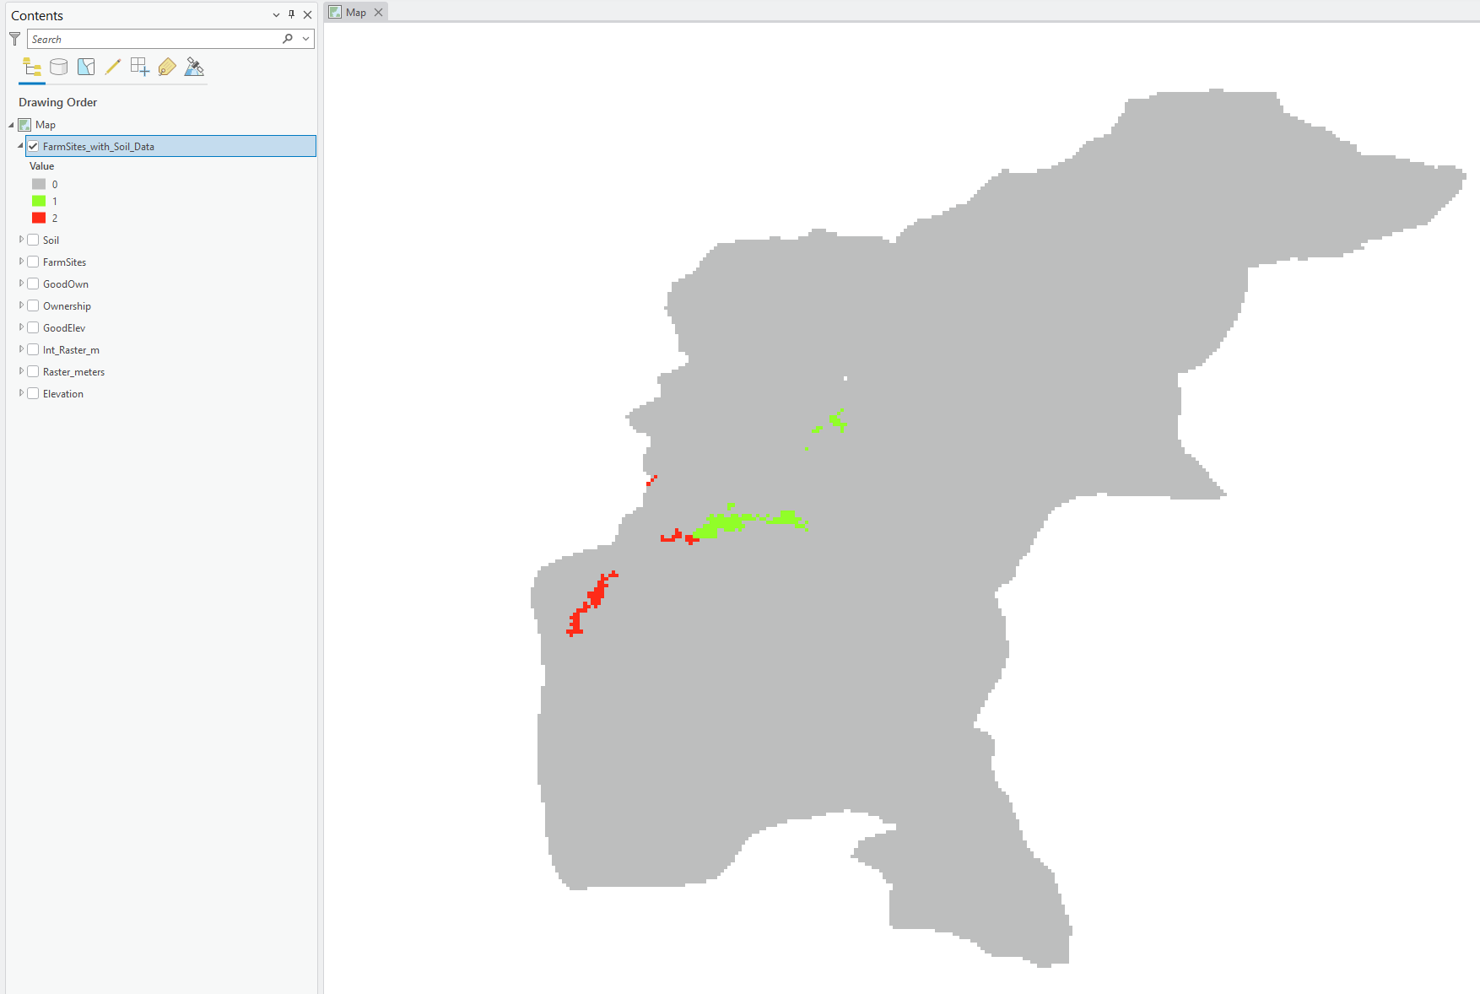

Let’s explore attributes:
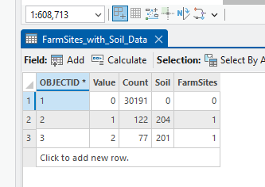

Notice how a unique value was created for every valid combination.

Over Tool
The Over tool works like a physical rubber stamp, where the values of the first input raster are "stamped" on top of the second input raster.
If the first raster has valid data (non-zero or non-null values), those values are kept in the output; however, wherever the first raster has a 0 (zero), the tool allows the values from the second raster to "show through".
This makes it an ideal tool for patching holes in a dataset or layering a new feature over an existing background while keeping the underlying data visible wherever the top layer is empty.
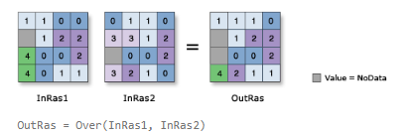

Goal: Use Over Tool.
Scenario: We have an existing Land use raster, update it with the Farm Sites Data.

Load Land Use data:
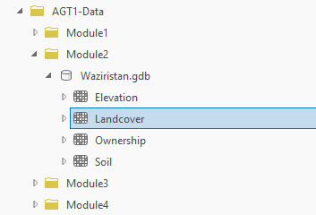
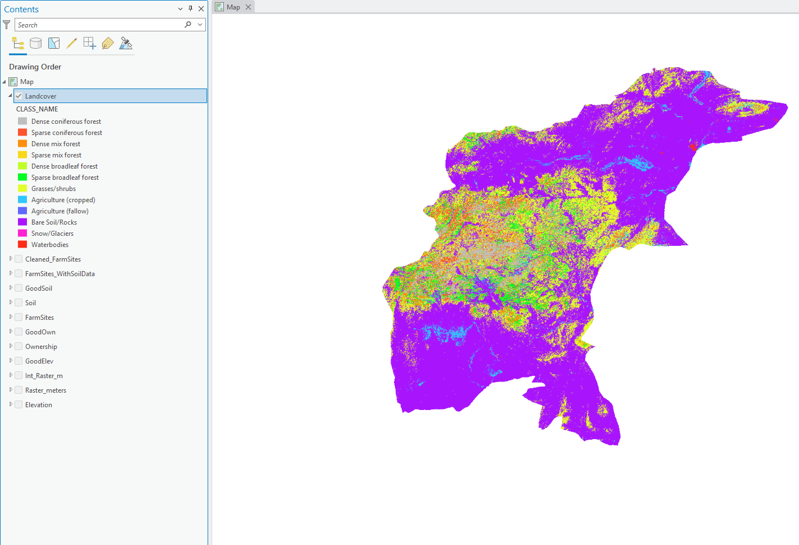
Open Over tool:
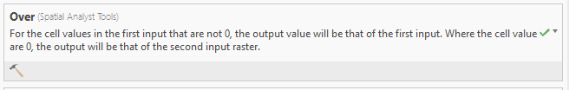

Configure as follows:
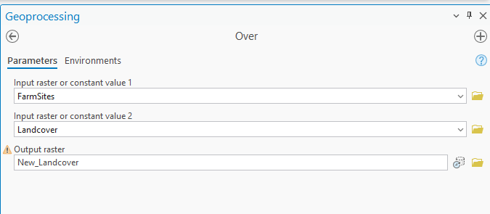
Hit Run:

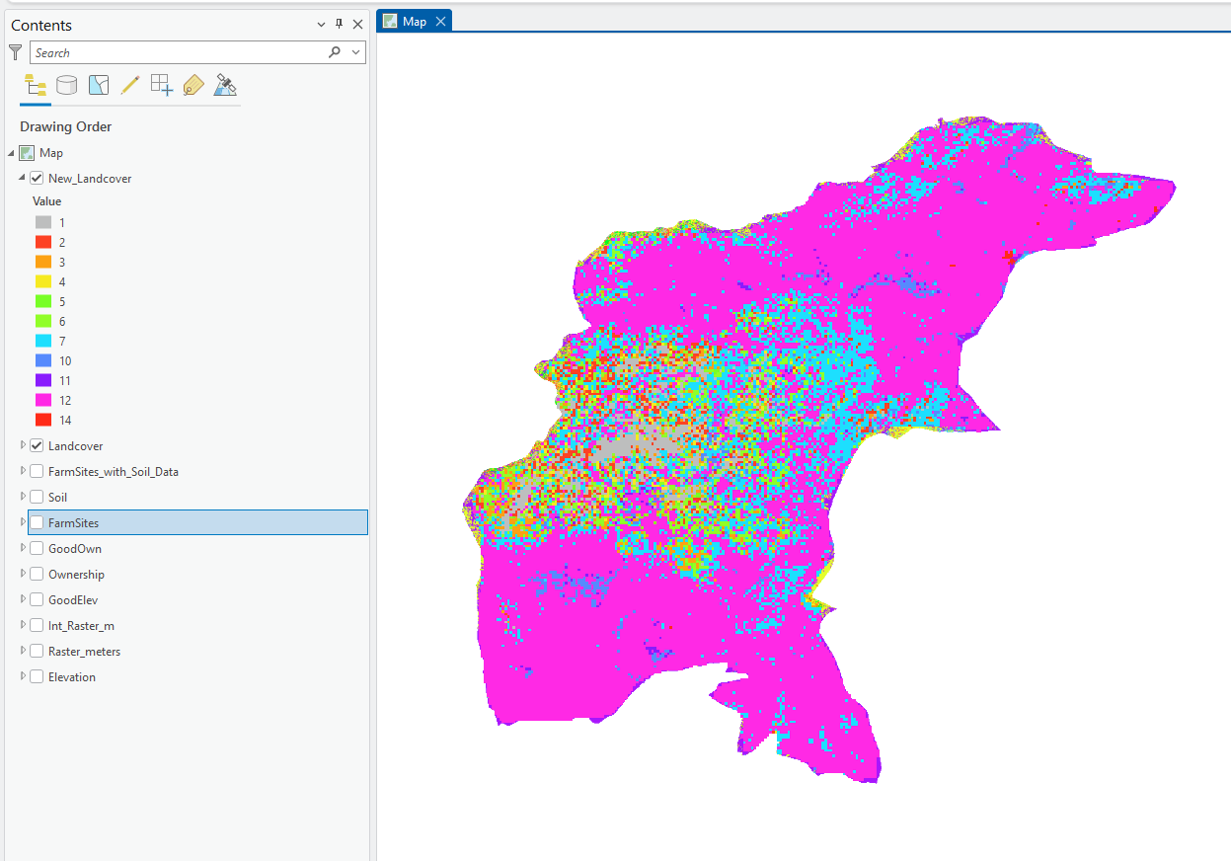
Compare the symbology of your output layer with that of the input Landcover layer. The OVER operator has replaced the Landcover cells that coincide with non-zero cells of GoodFarm with a cell value of 1.
Diff Tool
The Diff tool performs a cell-by-cell logical comparison to identify differences between two input rasters.
If a cell's value in the first raster is different from the corresponding cell in the second raster, the tool outputs the value from the first raster.
However, if the values are identical, the output cell is assigned a 0.
This makes it an excellent tool for change detection analysis, such as comparing land-use maps from two different years, allowing you to easily isolate areas that have changed while zeroing out regions that remained exactly the same.
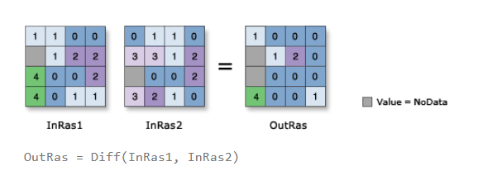

Goal: Use Over Tool.
Scenario: We have an existing Land use raster, update it with the Farm Sites Data.

Open Diff tool:

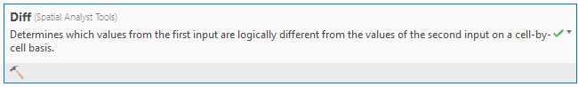
Configure as follows:
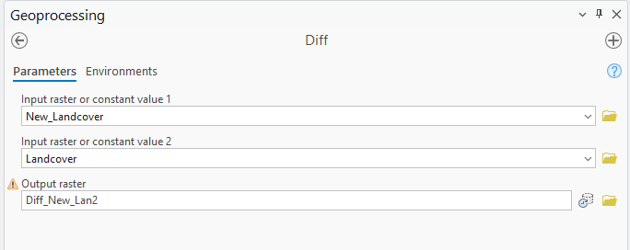

Hit Run:
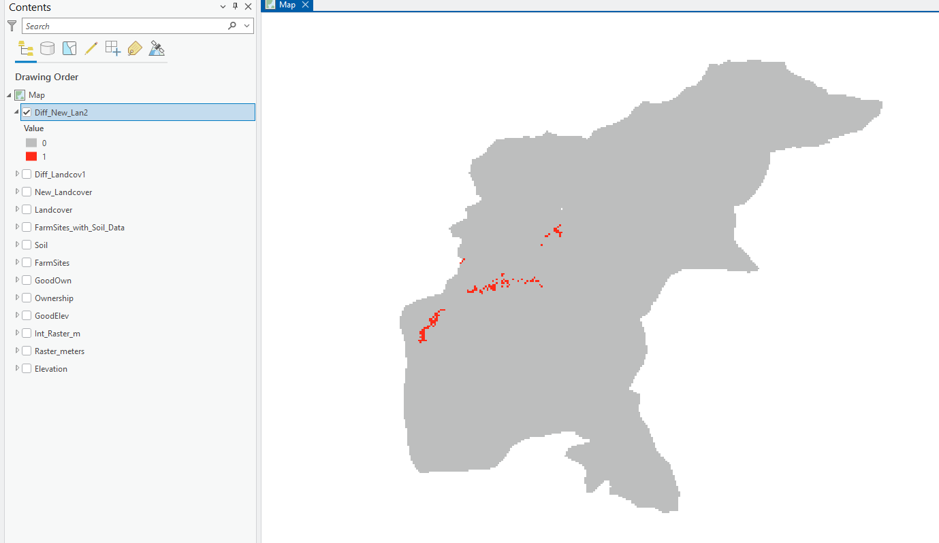

The result shows the values that were updated.

InList Tool
The InList tool determines which cells in an input raster match any of the values provided in a specific list of constants or other rasters.
If a cell value is found within the specified list, the output cell is assigned 1 (True); otherwise, it is assigned NoData (Null).
It is a highly efficient way to perform multiple "Equal To" operations at once, such as selecting several specific land-cover classes for a focused analysis.
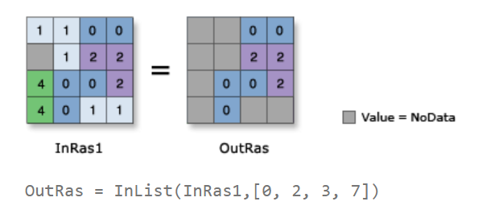
Goal: Use InList Tool.
Scenario: Certain soils, like Loam or Loamy Sand, are preferred for these species. Identify areas with only such soil types.

Load Soils (Raster):



Explore attribute table:


Note that in this exercise 201 & 204 correspond to Loam & Loamy sand. (The desired soils).
So we use the InList tool to find only these two soils:
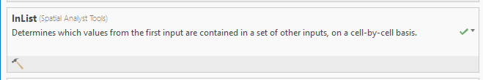
Configure as follows:
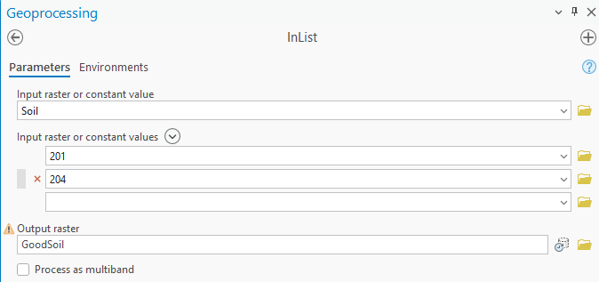

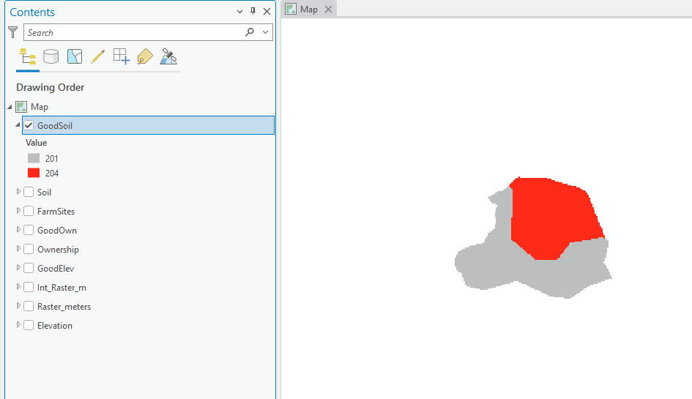
Note that it assigned NoData to all other cells.

Deliverables (To be submitted)
- Map showing use of each tool/operator. (Screenshot not Map Layout)

